ADVANCED DATABASES CSE 6331

PROJECT REPORT
PHASE 2

TEAM NUMBER: 4

NAME MAV ID
SAYALI KHADE 1001518264
MOHANA UPALE 1001556744

OUTLINE
- INTRODUCTION
  - High Level Description
- SYSTEM AND SOFTWARE USED
- DESCRIPTION OF ALGORITHMS
- EXECUTION STEPS OF EACH QUERY
- SCREENSHOTS
- REFERENCES
- APPENDIX

INTRODUCTION

HIGH LEVEL DESCRIPTION:
We had to edit a detailed University map for part of the UTA campus. The map included various buildings, playgrounds, administrative offices. The purpose of this project was to get an understanding of how to extract KML files from the Google Maps and convert them into shapefiles such that they can be used with Spatial Database tools like QGIS, Arcgis.
In order to create the maps we had to create the spatial objects like lines, polygons and points.
The project is divided into 2 phases :-
In Phase 1 we had to enhance the existing kml file of the assigned area.
In Phase 2 we had to convert the kml files into shapefiles and perform 3 spatial query operations
In Phase 1 our team was assigned with AREA – D
The initial KML file had the following marked:
Buildings like MAC, Physical Education and Trinity House.
The pathways to these building and their entrances.
The parking lots were marked.
Changes made to existing KML file
- The entry to off campus apartments were not marked in the previous KML file. They are now marked as D_Offcampus_E5 and D_Offcampus_E6.
- The entry points for Trinity House is added as D_Trinity House_E3 as points.
- Pathways for the entrance is added as lineString.
  - Pathway from Parking to MAC is added.
- We added the Athletic areas as the Volley Ball court, Basket Ball Court and Swimming Pool as Polygons.
- We have marked the lawn area as Polygons.
- We have marked the road Greek Row Drive as lineString.
In Phase 2 we performed spatial queries like :
a. Choose a building (by choosing it from a list (pull-down menu) of building names), and display the building requested in a highlighted color on the map.
b. Choose a building and a distance and return the names of all buildings or spaces of a particular type within that distance from the building (for example, find all "parking lot" type spaces within 2 miles from ERB building).
c. Choose two points (building entrances) using pull-down menus (for example ERB entrance 1 and Davis Hall entrance 1) and calculate and return a path that is the shortest path between the two buildings.
Also in Phase 2 we build a python GUI to query SpatialLite also store data in SpatialLite db and display the results using either QGIS or Arcgis

SYSTEMS AND SOFTWARE USED

1.QGIS 2.18.28 DESKTOP VERSION
2.ARCGIS PRO
3.VISUAL STUDIO CODE
4.QT DESIGNER WITH 2.18.28 CUSTOM WIDGETS
5.GOOGLE EARTH
6.PYTHON 2.7

DESCRIPTION OF ALGORITHM FOR ANSWERING ALL QUERIES

a. Choose a building (by choosing it from a list (pull-down menu) of building names), and display the building requested in a highlighted color on the map.
For this query we followed the algorithm stated below:
- Stored the Dropdown input user
- Created a database connection
- Set the path using setDatabase method
- Set the db path to ‘QSPATIALITE’
- Opened the db connection for the query execution
  - Executed the spatial query and returned the matched results with their ids
  - While the query had results
    - Stored the results in a list
- Displayed the result on QGIS using a plugin that we created

The user input for this query is building name that the user selects from the dropdown
The query executed is
query = db.exec_("Select id from Final_poly where name='{0}'".format(aptName));

Displaying the query result on selectedLayer “final_poly” where it selects the map by layer with the help of the id returned by the query which makes it easy to map on the QGIS the result.
The building is highlighted in green color.

b. Choose a building and a distance and return the names of all buildings or spaces of a particular type within that distance from the building (for example, find all "parking lot" type spaces within 2 miles from ERB building).
For this query we followed the algorithm stated below:
- Stored the Dropdowns input along with the text input given by user.
- Created a database connection
- Set the path using setDatabase method
- Set the db path to ‘QSPATIALITE’
- Opened the db connection for the query execution
  - Executed the spatial query and returned the matched results with their ids
  - While the query had results
    - Stored the results in a list
- Displayed the result on QGIS using a plugin that we created

The user input for this query is building name, building type and radius.
The query executed is
query = db.exec_("SELECT src.id,src.name From Final_poly src, Final_poly dest where st_contains(st_buffer(st_transform(dest.geom, 3857), {0}), st_transform(src.geom,3857)) AND dest.name='{1}' AND src.Btype='{2}' ".format(dist_range,aptName,aptType));

Displaying the query result on selectedLayer “final_poly” where it selects the map by layer with the help of the id returned by the query which makes it easy to map on the QGIS the result.
The outputs are highlighted in red color.

c. Choose two points (building entrances) using pull-down menus (for example ERB entrance 1 and Davis Hall entrance 1) and calculate and return a path that is the shortest path between the two buildings.
EXECUTION STEPS FOR THE QUERIES
In QGIS:
1. We added the layers by selecting ‘Layer’ -> Add Vector Layer -> Added the Dataset to the source.
2. We extracted the KML file into shapefile and saved them as ESRI shapefile for the 3 layers UTA_finalMap_polygon, UTA_finalMap_point and UTA_finalMap_line.
3. Then created database by selecting Database -> DBManager -> DB Manager
  - Expanded the SpatialLite under the tree options, right clicked on SpatialLite and added a new connection -> tested the connection.
  - After the connection was connected -> Imported 3 layers to the database.
  - It adds the geom column as well.

To create a python GUI plugin we followed the steps mentioned below :-
- Selected Plugins -> Manage and Install Plugins -> installed plugin builder and plugin reloader
- Set the setting for plugins as experimental plugin
- Selected plugin builder -> entered values for the fields like class name, plugin name, description, module name, author and email address.
- Clicked on Next -> entered ‘text for the menu item’ -> selected menu as ‘vector’->clicked on next->marked the plugin as experimental->clicked on next ->generate plugin
- Once the plugin is created opened the base.ui file in QT designer to design the GUI.
- Designed the GUI by dragging the dropdowns, text boxes, labels and buttons.

Plugin Builder is used to build our plugin ‘trial’ and reloader to reload the plugin to reflect changes we make any changes to the code or GUI.
To execute the queries, select the appropriate inputs from the dropdowns as per the queries and click on display which will highlight the areas on the QGIS layer files.

SCREENSHOTS
Code Files:
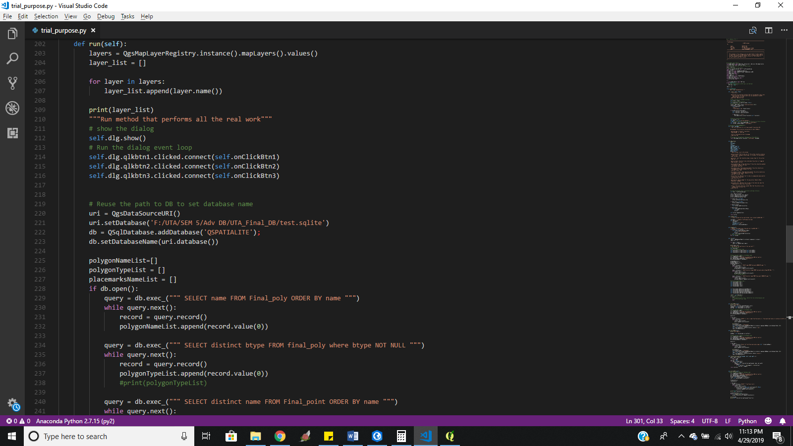

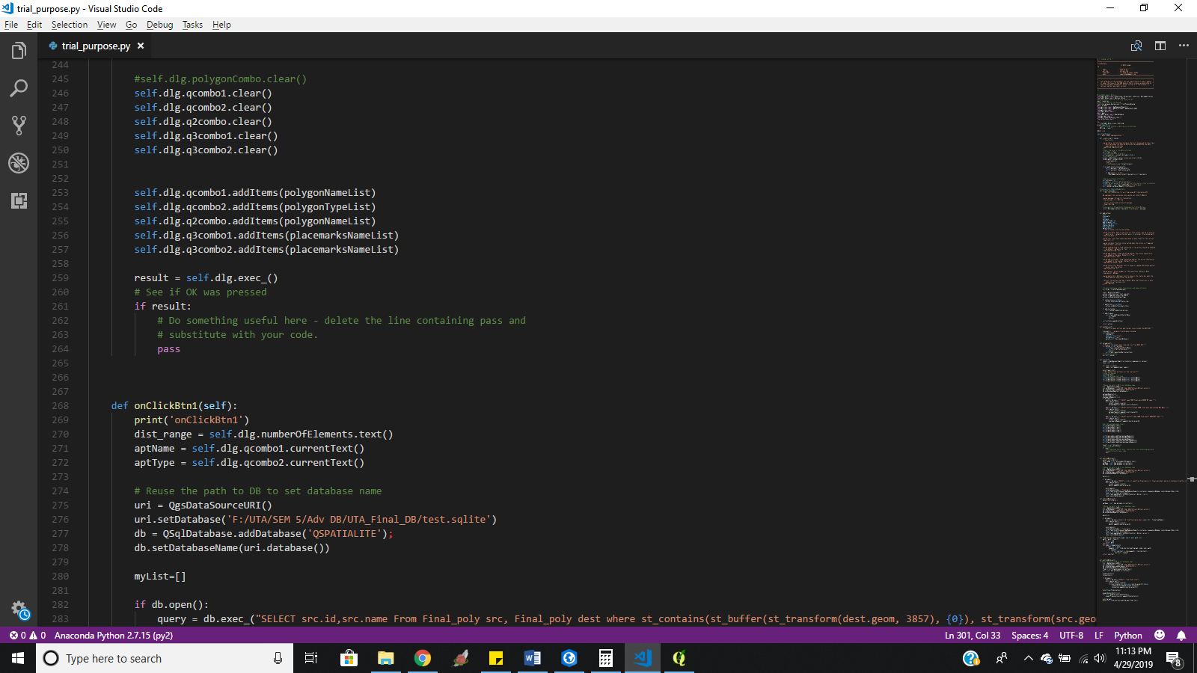

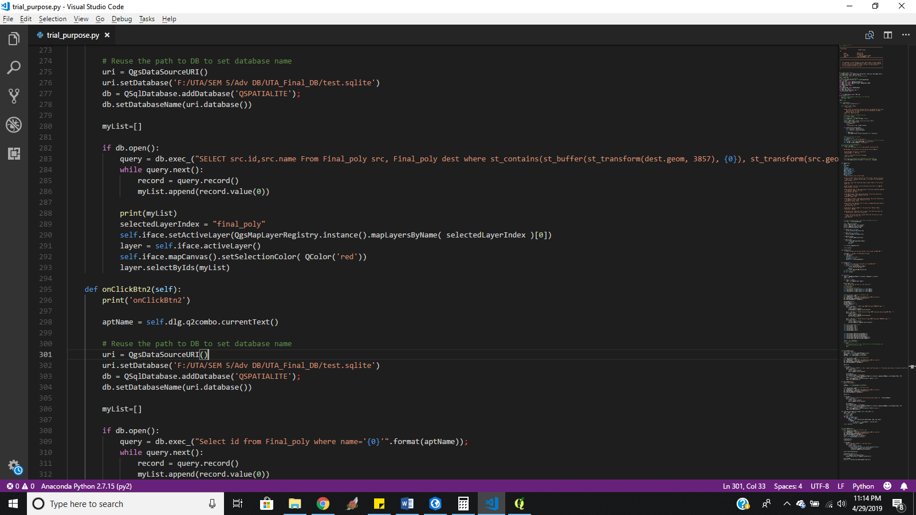

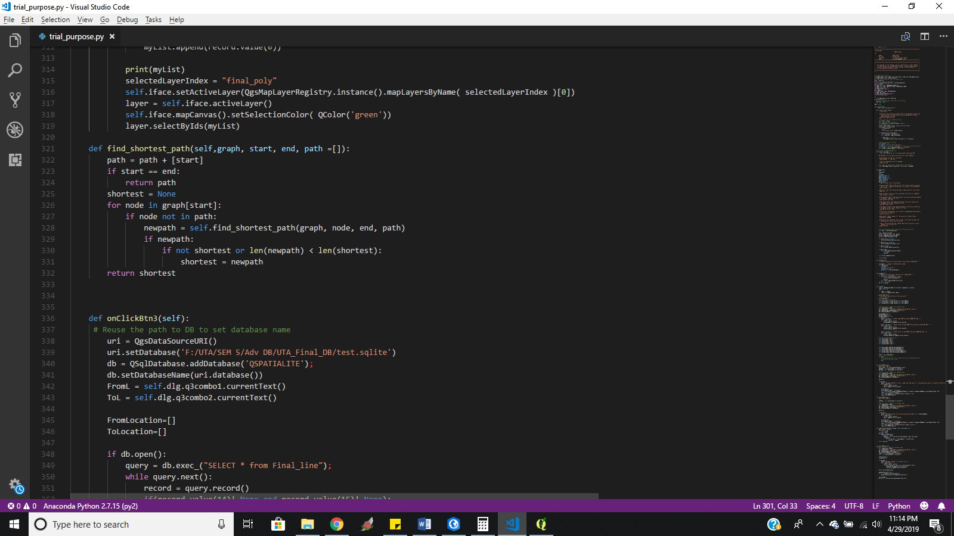

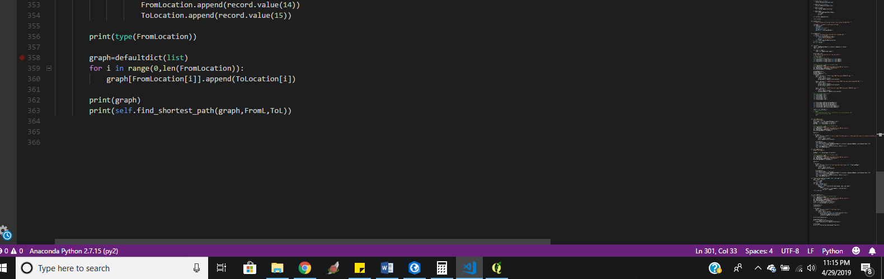

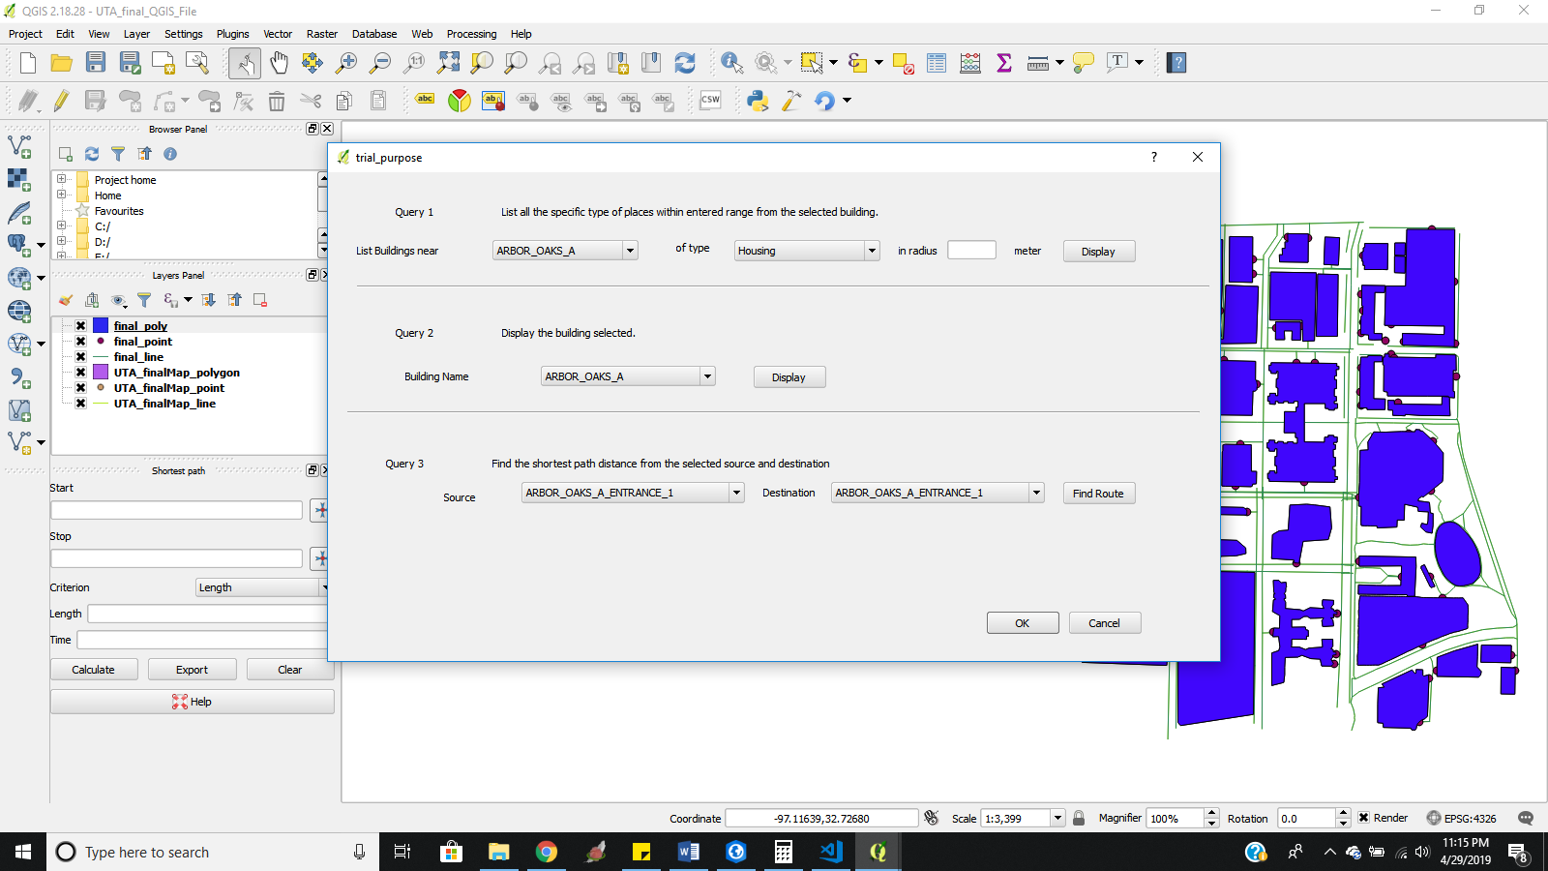
Query 1
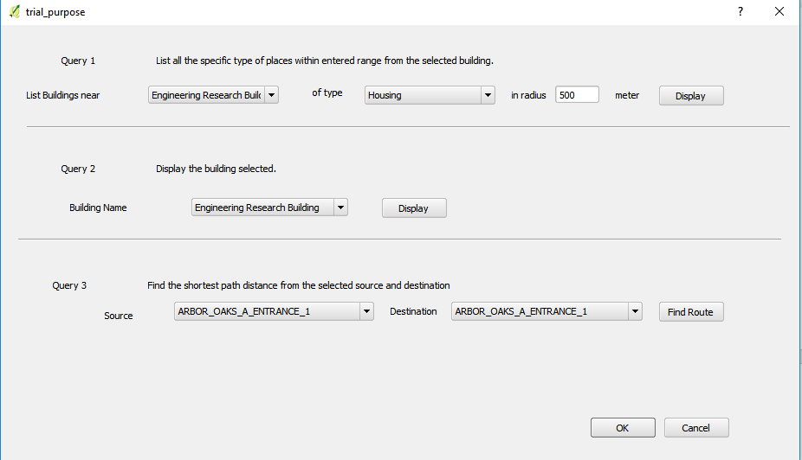
Result
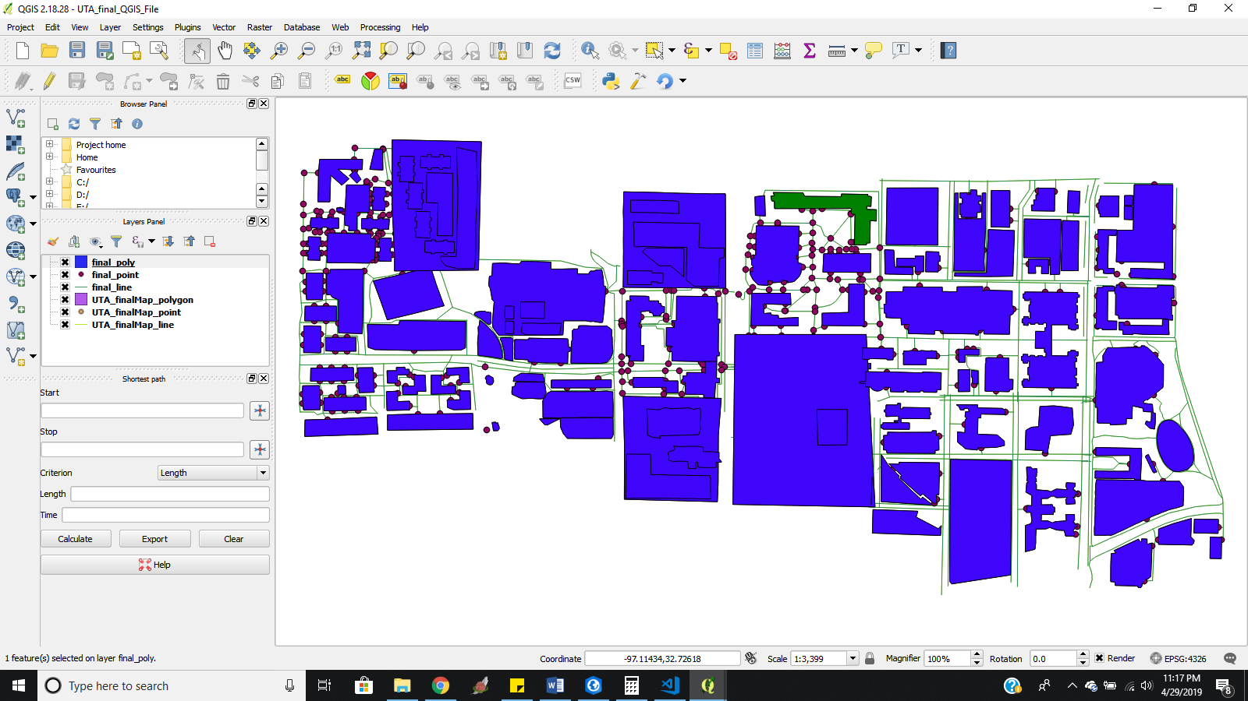
Query 2
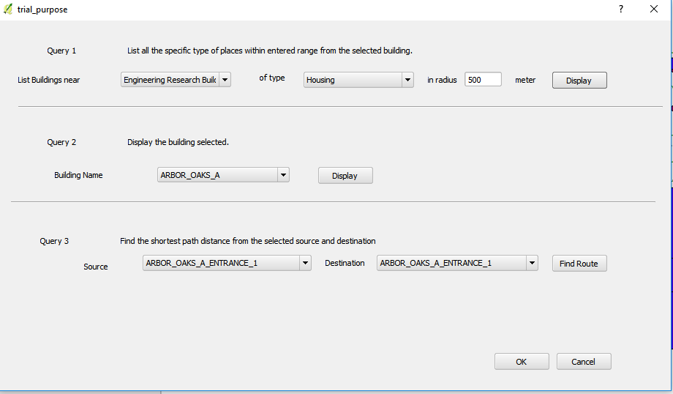
Result
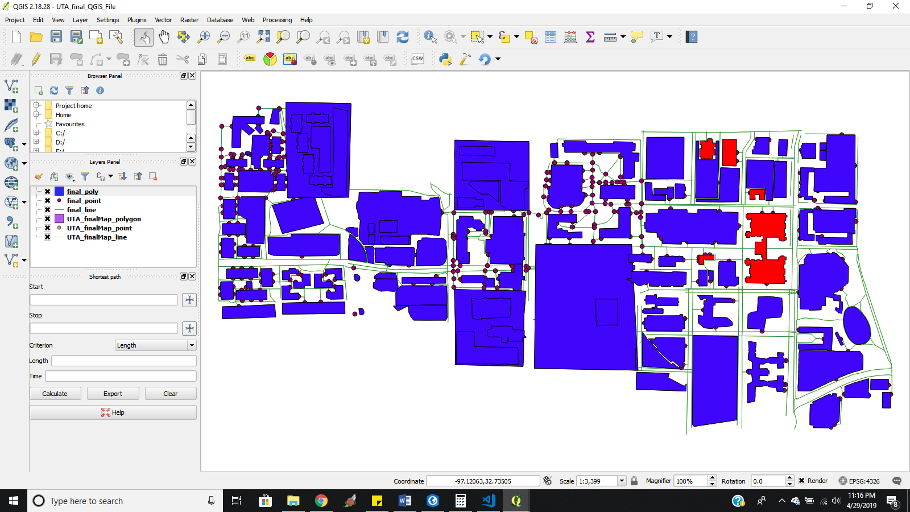
Query 3
Result

Query 3 with ARC GIS:
ARC GIS has the predefined network analysis for identifying the shortest path between 2 points.

Imported SHP files as layers in ARC GIS PRO

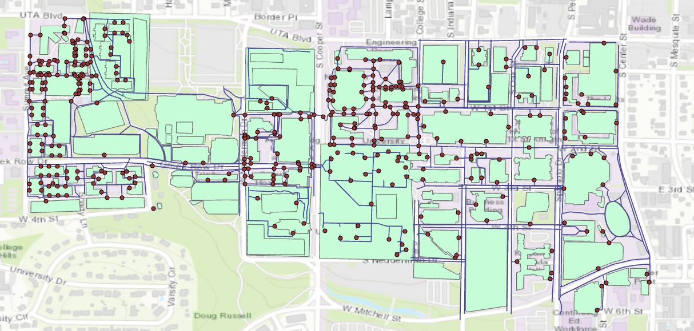

Procedure:
Step 1:
After importing the .SHP files as layers in the ARC GIS PRO, run the Network Analysis for the routes.
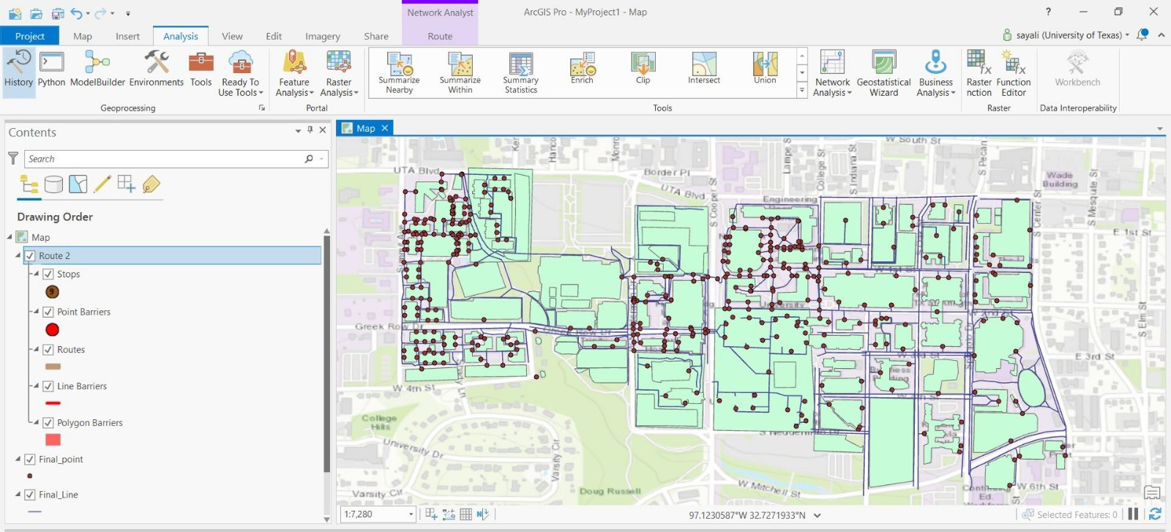

Step 2:
Select the starting point for the route using the select functionality in the map menu.
Step 3:
Using the Route menu generated after the route analysis, open the import stops and in the dialogue for add locations.
In this dialogue box put the route generated by the network analysis in the Input Network Analysis Layer.
In the text box for Input Locations add the SHP for the points.
Then click on the RUN button.
Step 4:
Select the destination point on the map and click on the RUN button in the ADD LOCATION dialogue box.
Step 5:
In the Ribbon for the ROUTE menu in the Travel Settings Part select the walking distance and Find best from the SEQUENCE drop down. Then click RUN button on the Ribbon.
This will generate the shortest path between the two points.
Result:
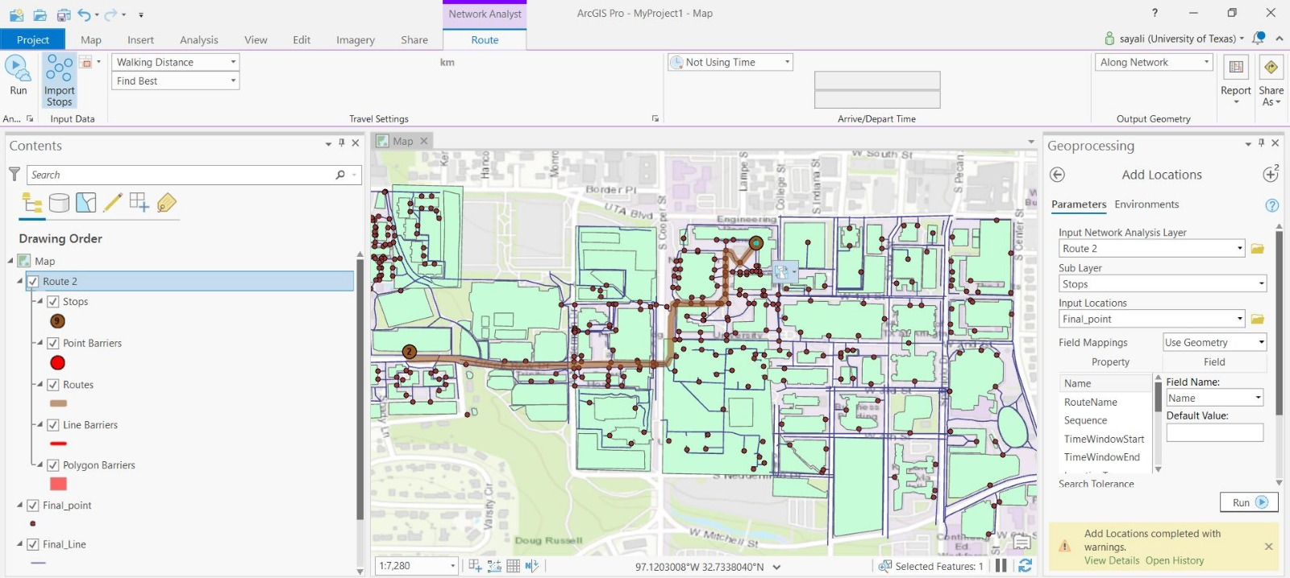

REFERENCES
- https://docs.qgis.org/2.18/en/docs/pyqgis_developer_cookbook/vector.html
- https://www.youtube.com/watch?v=ZI3yzAVCK_0&feature=youtu.be
- https://www.geeksforgeeks.org/generate-graph-using-dictionary-python/
- https://pro.arcgis.com/en/pro-app/help/analysis/networks/new-network-analysis-layer.htm
- https://pro.arcgis.com/en/pro-app/help/main/welcome-to-the-arcgis-pro-app-help.htm

APPENDIX

We have attached the following files :
1.Python GUI plugin that we have created -> trial_purpose plugin
2. Shapefiles generated
3.trial_purpose.py file
4. Database file
5.Arcgis folder MyProject1 for query 3

